***Note :* webdeploy-tutorial is naming placeholder for Web Api Project(you can choose whatever you want)**

***Publish via Web Deploy***

Now that you've made it this far we can finally get to the good stuff and use Web Deploy.

In **Visual Studio**, select the project in the **Solution Explorer** and either right-click it and select **Publish...** or in the navigation bar select **BUILD** and then **Publish webdeploy-tutorial**.

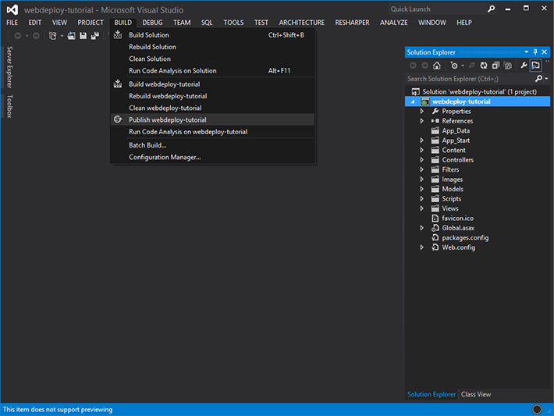

You should now see a new window **Publish Web**.

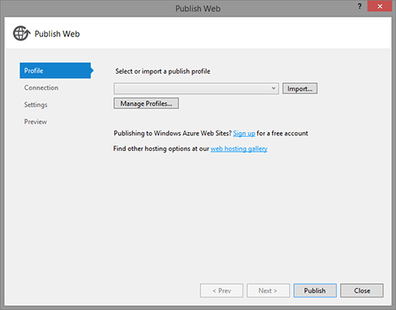

Click on the drop-down list and select **<New Profile...>**, enter a profile name webdeploy-tutorial - you guessed it - and click **OK**.

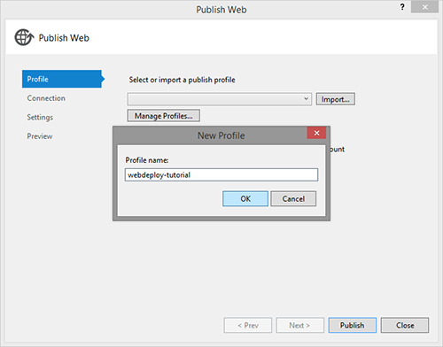

On the **Connection** screen you'll have to provide the connection details of the EC2 Windows Server instance and the name of the IIS website you want to deploy to.

Use your EC2 instance's **Public DNS** for the **Server** field (e.g.ec2-54-211-203-178.compute-1.amazonaws.com). The **Site name** is the actual name of your website in IIS, so in our case webdeploy-tutorial.

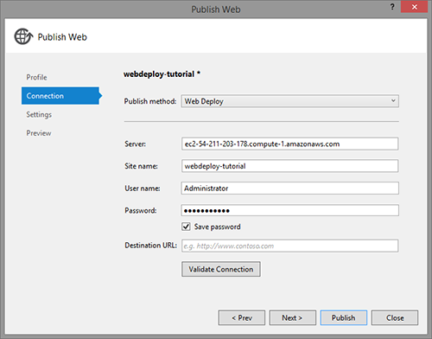

Press **Validate Connection**.

You'll most certainly get a warning about the security certificate:

*The security certificate presented by this server (ec2-54-211-203-178.compute-1.amazonaws.com) was issued to a different server  
The security certificate presented by this server was not issued by a trusted certificate authority*

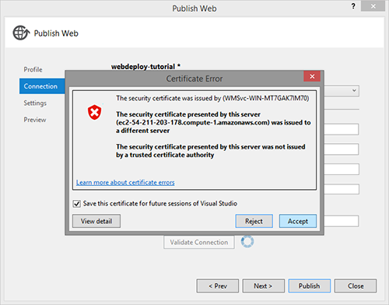

Take note of the warning, check **Save this certificate for future sessions of Visual Studio** and click **Accept**.

I particularly mean "take note" and not ignore it. Even if they are sometimes annoying or you've seen the same warning already a million times, notice them, skim over them and then make a decision. Never just ignore something and click ahead.

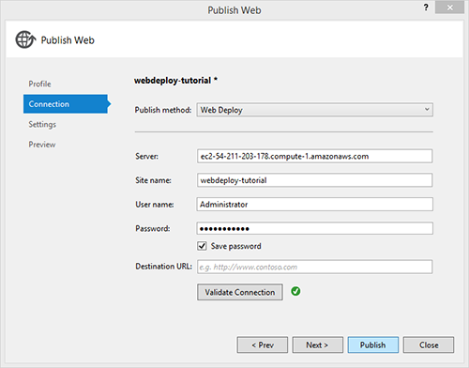

Now that your connection settings are validated you can click the **Publish** button.

You'll notice some Web Deploy specific activity in your **Output** window. I formatted the output a bit and reduced the noise so that we can better see what's going on here:

------ Build started: Project: webdeploy-tutorial, Configuration: Release Any CPU

------ Publish started: Project: webdeploy-tutorial, Configuration: Release Any CPU

Transformed Web.config.

Auto ConnectionString Transformed.

Start Web Deploy Publish the Application/package to

https://ec2-54-211-203-178.compute-1.amazonaws.com:8172/msdeploy.axd?site=webdeploy-tutorial

Publish Succeeded.

====== Build: 1 succeeded, 0 failed, 0 up-to-date, 0 skipped

====== Publish: 1 succeeded, 0 failed, 0 skipped

